SUMMER TRAINING PROJECT REPORT ON

“A STUDY ON EMPLOYEE SATISFACTION AT DIGITAL IMAGINATIONS 7 Fox pvt ltd”

Dr. A.P.J. Abdul Kalam Technical University, LUCKNOW
For the partial fulfillment of the requirement of Masters of Business Administration
MBA Batch: 2021-2023

UNDER THE SUPER VISION OF
DR YOGESH PURI

STEP-HBTI, KANPUR

Submitted By: VAISHNAVI

MBA 3rd Semester



Science and Technology Entrepreneurs Park HARCOURT BUTLER TECHNICAL UNIVERSITY, Nawabganj, Kanpur, Uttar Pradesh 208002

DECLARATION

This is to certify that present thesis titled “A STUDY ON EMPLOYEE SATISFACTION 7 FOX PVT LTD” is based on original research and has not been submitted in part or whole for any diploma or degree of any university. The works of other authors, wherever they have been made use of in this study, have been duly acknowledged at relevant places.

Date:
Place:

ACKNOWLEDGEMET

The research report on “A STUDY ON EMPLOYEE SATISFACTION AT DIGITAL IMAGINATIONS 7 FOX PVT LTD ” has been conducted by me. I am thankful to DR.YOGESH PURI (Faculty) and all faculty members of MBA Department who helped me to materialize this report. I am also thankful to all those people who directly or indirectly helped me during my research report.

VAISHNAVI
MBA 3 rd Sem.

PREFACE
Secondly, I would like to convey my sincere thanks to all the employees of DIGITAL IMAGINATIONS

CONTENTS

TOPICS PAGE NO.

- Company Profile 1-14
2. Introduction 15-29 3. Literature Review 30-
4. SWOT Analysis 53-77
5. Objective of the study 82-91
6. Scope of the study
7. Research Methodology
8. Use and Important of study 92-93
9. Analysis of data collected 10.Findings
11. Conclusions
12. Bibliography
12. Annexure 97

COMPANY PROFILE

COMPANY NAME - DIGITAL IMAGINATIONS

INDUSTRY - ADVERTISING SERVICES

FOUNDED ON - 2020

HEADQUARTER - KANPUR, UTTAR PRADESH

TYPE - PRIVATELY HELD

APPLICATION - KISLIYE CASHBACK

FOUNDER - MR. RAJAT SINGH

DIGITAL IMAGINATIONS



“Owned by you, Driven by us”

Digital Imaginations is a registered company in India as 7 Fox Solutions Pvt.Ltd. Digital Imagination was founded on October 2020. It is a digital marketing agency situated in Kanpur, Uttar Pradesh. Digital imagination is a manifesto of digital marketing and creative agency, formed to provide revenue generating and branding marketing and creative solutions to businesses. Its sight is to help local vendors and audience to grow their business through digital services at low rate and to solve the queries of the user’s. It is very affordable, and have budget friendly marketing plan’s to promote your business online on digital platforms like face-book, instagram, you-tube, etc…..Digital Imaginations are serving SAAS in the field of Marketing and Fin-tech. Kisliye Cashback ventured owned by Digital Imaginations, Kisliye Cashback is a platform that endorses local shopping stores and provides instant cashback, discounts, and other rewards of their local region to the users.

VISION & MISSON



VISSION
It has been made keeping in mind that shopkeeper who can’t afford extortionate platforms. We attempt to understand the unique needs of the small vendors and translate that needs into a platform which satisfies them in the form of a platform, high level of service and affordable price range in a unique way.

MISSION
Digital Imagination is formed with a mission to provide a platform to all business vendors, who want to enlarge it digitally. To treasure consumer understanding as one of our most valued assets and thereby exerting every effort to understand consumers' dynamic requirements to enable us in offering maximum satisfaction.

•To offer a platform at affordable price by strictly maintaining an uncompromising stance. With continuous R&D and innovation we strive to make our website and complying with international quality standards.

 To maintain a congenial working environment to build and develop the core asset of Digital Imaginations – its people. As well as to pursue for high level of employee motivation and satisfaction.

•To sincerely uphold the responsibility towards the government and society with utmost ethical standards as well as make every effort for a social order devoid of malpractices, anti-environmental behaviors, unethical and corruptive dealing.

KISLIYE CASHBACK

LOCAL SHOPPING PAYMENT APPLICATION



Shopping is easy when Kisliye cashback offers CC’ cashback/coupons.

Kisliye cashback was founded on December 2021. This venture is owned by Digital Imagination, Kanpur, which is founded on 2020. A digital marketing agency situated in Kanpur, Uttar Pradesh. We hold the portfolio of more than 20 clients. By this journey 2020 to 2021 we get the idea of this application. We are working on this application for providing best services to our users and our struggling vendors.
Kisliye Cashback is a local shopping payment app. It works like a digital wallet and helps in making cashless and digital payments. It offers mobile payment services to consumers and enables merchants to receive payments. It makes payment easy and also promises to secure information of our user’s. It not only gives you 10% instant discount but also give mind blowing and fruitful rewards and coupons’. It is very beneficial not only for the users but also for the shopkeepers. It will upgrade the productivity of shopkeepers and also promote their shops. Our vision is not to grow ourselves but also to others grow as well. We will act as a helping hand to the local businesses, startups, ventures who are struggling to the market. Kisliye cashback is presenting themselves as a helping hand to the users and the struggling vendors. It makes shopping easy and fruitful by offering saving solutions to its customers, and provides growth opportunities to their nearby vendors. It will give instant cashback and other rewards from local area shops, small as well as large businesses. Kisliye cashback is going to bring digital revolutionary change in payment method.
It is a platform that endorses local shopping stores and provides instant cashback, discounts, and other rewards of their local regions to the users. Kisliye Cashback gives you opportunity to save your money on this purchase and spend on your next purchase.

Kisliye Cashback has an add on for the retailers

One QR; One Application: - The QR is designed for the vendors and the application is designed for the users to cut down the fraudulent activity. With the help of this feature the QR get connected to the user’s application and will provide ease in usage.

Full secured: - It is using one of the most advanced security infrastructures. It has ISO 27001 certification and PCI-DSS compliance which makes your account details and payment 100% secure , and we will make every effort to make sure it stay like this.

Secure Payment: - It is using one of the most advanced securities
Infrastructures. It has ISO 27001 certification and PCI-DSS compliance which makes your account details and payment 100% secure , and we will make every effort to make sure it stay like this.

Instant Cashback Up to 10 %:- Pay your shopping bills with Kisliye cashback and get instant cashback up to 10%, and it also provide exciting rewards and useful coupons nearby your merchants.

Nearby shop discount code: - Pay with Kisliye cashback and it provides you coupons’ as per your convenience that too in the shops nearby you. We serve best not to you only but also to your nearby merchants.

Easy monitoring: - Kisliye cashback has advanced feature, with the help of which vendors can generate the transaction data of whole month. With the help of this application, vendors can figure out which items have sold the most and in which month they have sold the most.

MISSION VISSION



KISLIYE CASHBACK MISSION STATEMENT: - Kisliye cashback is formed with a mission to make a highly regarded position in the market by targeting city to city, to enhance the productivity through local vendors.

KISLIYE CASHBACK VISSION STATEMENT: - Kisliye cashback have a vision to provide a position to local vendors in all over India and to build a large & open transaction for users to create a positive image.

INTRODUCTION

Since the most important factor for any service sector is to retain the trained and experienced employees and hence increase productivity. If majority of the employees are dissatisfied then they will eventually quit the company in future and this is a big threat for a company as they are the people who provide the services and earns profit for the company. In this phase when employee’s expectations are not met by the organization and vice versa then various disputes take place. These disputes may cause loss of workforce, wages and production. This is also true to the corporate sector.
The study of job satisfaction among corporate employees is important because there are various aspects of the job that are highly attractive and lead to satisfaction and aspects of the job that lead to dissatisfaction. Positive aspects include the opportunity to work in corporate and employees to accomplish common goals, developing corporate background and the ability to work with coworkers.
It is important to identify which factors contribute to job satisfaction as well as those that may lead to job dissatisfaction to assure that the manager-ship is attractive to potent. There are many variables that have been hypothesized to be a result of job satisfaction or dissatisfaction. It is an established fact that the success of any organization depends on the satisfaction of its work force. The aim of this study is to determine that organization employees are satisfied with their job and also to identify those factors that are of high concern to bank employees regarding their satisfaction this study attempted to evaluate job satisfaction of employees of the Digital Imaginations 7 fox pvt ltd. The concept of employee relations suggests how the organization is managing all kinds of employment relationships with its people. It focuses on the benefits that can be provided to the people at the individual level through better quality of work life, opportunities for professional development and better career prospects, so that in turn they can contribute for organizational benefits through improved market share of the product, competitive edge and better dividends for stockholders. One of the prime focuses of the HR division is to build positive culture within the organization. It takes steps to influence positive emotions of the employees so that they are committed to put best of their capabilities, are loyal and less likely to leave the organization. Some of the measures for creating such a positive culture is through sustaining employee empowerment, recognizing and rewarding employees for their proactive ideas, actions, superior customer service and work processes.
The company organizes an ESAT (Employee satisfaction) survey- a process to know the employee engagement ratio. Employee engagement ratio gives an idea on how far people are both productive and psychologically committed.
Apart from fixed salary components which encourage good talent, variable pay continues to be the biggest single motivating tool for the employees. The organization has compensation package which apart from the basic salary has other components like accommodation, medical benefits and perquisites. But money apart, it also has several other interesting things to promote team spirit and high employee involvement. The top management regularly addresses the employees to discuss on various issues like organizational objectives, strategies, likely innovations, problems concerning work etc.
Fun at work- similarly it organizes various competition, programs, events to mitigate dull work and strike a organization between work and life. These events not only provide the people a break but also foster a feeling of belonging amongst the employees. Leisure and motivation events are also held regularly.
Employee Well-being, hygiene & Safety the HR dept. undertakes the administration of several employees well being schemes.

Job Satisfaction
Employee satisfaction or job satisfaction is, quite simply, how content or satisfied employees are with their jobs. Employee satisfaction is typically measured using an employee satisfaction survey. These surveys address topics such as compensation,
Workload, perceptions of management, flexibility, teamwork, resources, etc. These things are all important to companies who want to keep their employees happy and reduce turnover, but employee satisfaction is only a part of the overall solution. In fact, for some organizations,
Satisfied employees are people the organization might be better off without. One of the most widely used definitions which is "A pleasurable or positive emotional state resulting from the appraisal of one's job or job experiences".

There are two types of variable
Dependent Variable
Independent Variable
- Levels of job satisfaction are dependent variable.
- Factors of job satisfaction are independent variable.

Factor of Job Satisfaction
- Work Environment
- Pay and Salary
- Fairness
- Promotion Criteria

Literature Review

Job satisfaction is one’s feelings or state–of-mind regarding the nature of his work. It is a self reported positive state resulting from the appraisal of one’s job or from one’s job experience. When an employee finds his or her job interesting, rewarding and reliable- this state of the employee is that he or she is satisfied in his or her job. Thus, job satisfaction comprises many factors such as Respect, Trust, Security, Healthy environment, Career path, Pay and benefits etc. Employee satisfaction is an important success factor for all organizations. According to Choudhary, B., (2013), employee satisfactions have been recognized to have a major impact on many economic and social phenomena, e.g. economic growth and higher standard of living.
Companies must continuously employee satisfaction in order to stay profitable. The two-factor theory effectively delineates the reasons job satisfaction. There are motivational and hygiene factors present in one's job. Rewards and benefits are hygiene factors, so if they are not present, they will bring dissatisfaction, but their presence will not necessarily bring job satisfaction. Job Characteristic Model (JCM) has been used to determine the level of job satisfaction (Sharma, A., & Khanna, M. 2014). The model focuses on five cores job dimensions, skill variety, task identity, task significance, autonomy, and feedback, which in turn influence three key psychological states: experienced meaningfulness of the work, experienced responsibility for the work, and knowledge of results (Monga, A et. al., 2015). These psychological states then influence job satisfaction. Job satisfaction has been studied both as a consequence of many individual and work environment characteristics and as an antecedent to many outcomes.
Satisfaction level increased as the person grew old where in the variables like gender, time in hospital, position help were controlled. Organization should always focus on satisfying the basic needs of an employee which will in return helps in resolving the conflicts and confusion.

- SWOT Analysis:



A SWOT analysis helps find the best match between environmental trends (opportunities and threats) and internal capabilities.

- STRENGTHS:
- Strength is a resource or capacity the organization can use effectively to achieve its objectives.
- The strengths of a company are the most important building blocks required for growth to take place. The following are a few of the most prevalent strengths that Digital marketing 7 Fox pvt ltd has at the present time.



- Recruitment: Their recruitment and selection policy is very strong. Digital marketing recruits talented candidates from the market through proper testing- written and interview. The written part contains questionnaires that are of IBA standard which is a renowned education institution of our country.

- Work environment: During my stay I found the work environment very satisfactory. Everyone is cordial and helpful and cooperative. There is less internal conflict or politics at play which is essential for conducting a productive working environment.

- Transparency: For clear communication to the employees of the HR Practice in Digital marketing, they have a service rule book which they give to every employee. The guide articulates important and covers all HR Practice followed by the organization. This is very helpful both for the employees and the employer as it removes chances of misinterpretation, bias etc.

- Leave Management: They Provide a 44 days leave balance which include earn leave 20 days, Casual leave 10 days and Medical leave 14 days. So employees have no worries regarding having leaved.
- Accountable Corporate Governance is very important for the DI: Good Corporate Governance is an issue of vital importance to the Board and Management of Digital marketing. The Board of Directors, as the head level of authority, is responsible and accountable for the overall direction and is ultimate answerable to regulatory authorities and shareholders for the activities, strategies and performance of the company.

.

- Training and development system of Digital Imaginations:
- Digital imaginations are a digital marketing and creative agency it sight is to help local vendors and audience to grow their business through digital services at low rate which provides the online services to its customers. By using the modern online services, where small vendors can grow their business digitally. This service gives small vendors, merchant’s huge flexibility. More and more urban customers are becoming attracted to this service day by day. This online service provides great benefit for the vendors, as they do not have to face the hassle of going to the office to know their balances.

- WEAKNESS:



- Though Digital Imaginations 7 fox pvt ltd.is a company that has much strength but it also has some weakness. The followings are few of the most common weakness that digital imaginations has at the present time:
- Inadequate human resources: The human resources are not sufficient in terms of its service providing system. It has to maintain a number of formalities to recruit employees.
- Human Resource Planning:
- There is not much Human Resource Planning at the Organization except for an annual need assessment for required workforces

- Investors lack of knowledge about Digital Imaginations 7 Fox pvt ltd.

- Digital Imaginations 7 Fox pvt ltd. is a new digital platform, So, it’s new to the investors. They don’t have the idea how it works. Their concept about digital marketing is vague and they have a very pessimistic notion.

- Fund is still small:

- Though Digital Imaginations 7 Fox pvt Ltd is managing the digital marketing agency which has the goal to help local vendors to enhance their business digitally but the fund size is still small. Investors have the no idea about Digital Imaginations businesses.

- Lack of Job Analysis:
- It is the important part of HR practice in an organization but not implanted in Digital Imaginations which means they are less informed about current market trends and that could lead to loss of potential talents from their pool.

- OPPORTUNITY:



- In an organization opportunities are positive external environmental factors. An organization should explore all possible opportunities available to it. These opportunities are intended to improve the organization. By making improvements, the organization should be able to become more competitive in the market. The following are available opportunities to digital imaginations in order for it to become more aggressive:

- Recruitment:
- Most recruitment in here is through internal recruitment, they can spread the pool of entry level employees through campus recruitment.

.
- THREATS:



- An organization’s threats are negative external factors. An organization should explore all possible threats available to it. These threats are intended to diminish the organization. By making improvements and proper monitoring of the threats, the organization should be able to turn more competitive in the market. The following are threats are available to Digital Imaginations 7 Fox pvt Ltd in order to threaten its existence.

.

- The Lack of Motivation of Employees:
Sometimes the lack of motivation in employees can create a threat to the organization. Employees may be overburdened with tasks that are not their core-competencies. As a result, the quality and accuracy of deliverables duties may fall. Employee turnover may have a negative effect on the overall performance of organization

Objective of the study
Broad objective:

The broad objective of this study was to identify the employee job satisfaction level of Digital Imagination 7 Fox private ltd.

Specific Objectives:

i. To examine the overall level of Employee Job Satisfaction of Digital Imaginations 7 Fox pvt ltd.

ii. To sort out some ways of improvements of employee job satisfaction of Digital Imagination 7 Fox pvt ltd.

iii. To analyze the relationship between organizations job factors and the jobs satisfaction of employee

Research Methodology

Methodology includes direct observation, face to face discussion with different employees of different departments, study of files specially leave files of employees and settlement files. A structured Questionnaire is used for collecting different information about identifying job satisfaction and others sensitive issues. Questions measuring factors on a Likert scale ranging from 1 to 5 where 1 mean strongly agree and 5 means strongly disagree

Importance of Job Satisfaction

Employee satisfaction is of utmost importance for employees to remain happy and also deliver their level best. Saari, etc. al., (2014) stated that satisfied employees are the ones who are extremely loyal towards their organization and stick to it even in the worst scenario. Employees need to be passionate towards their work and passion comes only when employees are satisfied with their job and organization on the whole. Employee satisfaction leads to a positive ambience at the workplace. Keeping workers happy helps strengthen a company in many ways, including:
➢ Lower Turnover – Turnover can be one of the highest costs attributed to the HR department. Retaining workers helps create a better environment, and makes it easier to recruit quality talent and save money. The bottom line: satisfied employees are typically much less likely to leave.
➢ Higher Productivity – Irrespective of job title and pay grade, employees who report high job satisfaction tend to achieve higher productivity.
➢ Increased Profits – Keeping employees safe and satisfied can lead to higher sales, lower costs and a stronger bottom line.
➢ Loyalty – When employees feel the company has their best interests at heart, they often support its mission and work hard to help achieve its objectives. And, they may be more likely to tell their friends, which helps spread goodwill.
It is the responsibility of the management to design the environment in such a manner that it reduces the dissatisfaction where in the work tasks, working patterns are properly mentioned.
The employees satisfaction level and career satisfaction level was much more in enthusiastic workaholics.

Limitations of the study

Although effort was made to make the report as comprehensive as possible, nevertheless, there were a few impediments that made trouble to set up a report easily including the time constraint of the study hindering the course of vast area. Although having much co-operation from the officials, they were not able to give enough time, as they were busy with their works. Data unavailability was another big issue there because company might not want to disclose all the confidential information regarding their managerial strategies and plans. There has lack of depth knowledge and analytical ability for writing such report. As my sample size was 20 it was difficult to draw a conclusion. While collecting data on Digital Imagination 7 Fox pvt ltd, did not disclose much data for the sake of the privacy of the company

.
Data Collection
The following sources have been used for the purpose of gathering and collecting data as required.
Primary sources:
Face to face conversation with the respective officers of the branch.
Exposure on different desk of the office.

Secondary sources:
 Various publications on corporate operation,
 Various books, journals and articles about corporate activities.,
 Website of Digital Imaginations.
 Relevant file study as provided by the officers concerned

Sampling Design
Target population: All employees of Kalyanpur branch Digital Imaginations.
Sample Size: There were 50 respondents.
Sampling Procedure: “Convenience Sampling Procedure” was used for this study to collect data from the respondents.

EMPLOYEE RELATIONS

Findings

From the analysis it is noted that employees are satisfied with the given resources and tools to work, highly appreciated with their job at bank, working environment & culture, company pay structure and promotions. But they are a little bit dissatisfied in some matters such as: performance appraisal, job security, financial and non-financial facilities etc. Most of the employees were satisfied towards the work assigned to them by the management. Therefore, the variables including proper remuneration, Incentives, skills development, working environment, performance appraisal system, balance between family life and work life etc.
have a great influence on employee job satisfaction.
After this survey and analysis, some common findings are summarized as follows:
i. Most of the employees think that, though they have training related to job, there has lack of advanced training to develop their expert knowledge.
ii. Increment rate is not clear to all employees. There has a gap of increment issue among all employees.
iii. Employees fear about their job security and they think the benefits offered by the corporate are not standard with their job.
iv. Besides, there has no canteen of its own. Transport facilities are not available for all.
v. Existing employment policy and employee disciplines of AIBL are at moderate level.
vi. Performance appraisal system of AIBL doesn’t motivate employees to do a better job.
vii. Most of the employees are not comfortable with assigned job responsibilities and leave packages and work schedules.
viii. Employees are afraid of their long term benefit program.
ix. Employees are confused about their promotional opportunities and professional growth in the corporate career.

.

Data Collection is the collection of necessary detail to gain further information. This requires both primary and secondary data.
A. Primary data:
Questionnaire and personal interview.

B. Secondary data:
Periodicals, journals, newsletters and official documents of DIGITAL IMAGINATIONS., helped me in secondary data collection.

Field Work:

Fieldwork is done for the purpose of collection of data. The fieldwork involved here are:

- Regular research to gather information on the relevant topic and have them compiled according to the project specification.
For getting proper guidance for the project, often discussion with the guide was done.

DATA ANALYSIS AND INTERPRETATION

Q1) Age of the employees

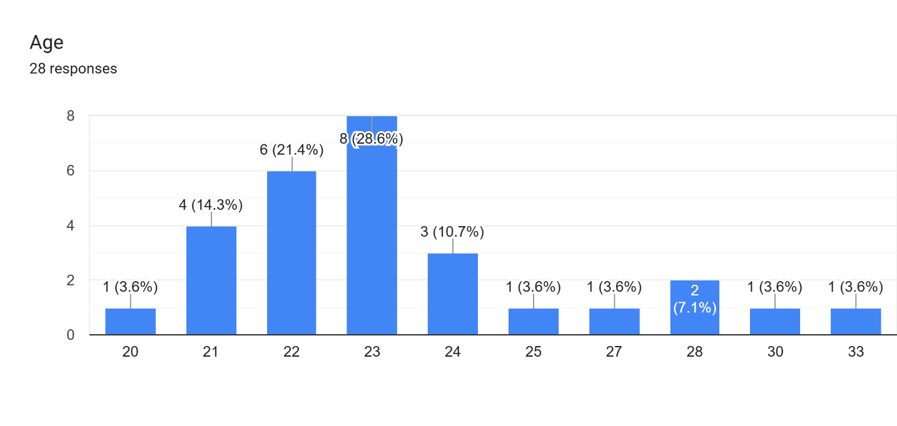

14 out of 150 find it easy, 35 find it average and 65 find it difficult. So from the above we can deduce that it was difficult as most of them found it so.

Q2) Gender of the employees

- Male
- Female

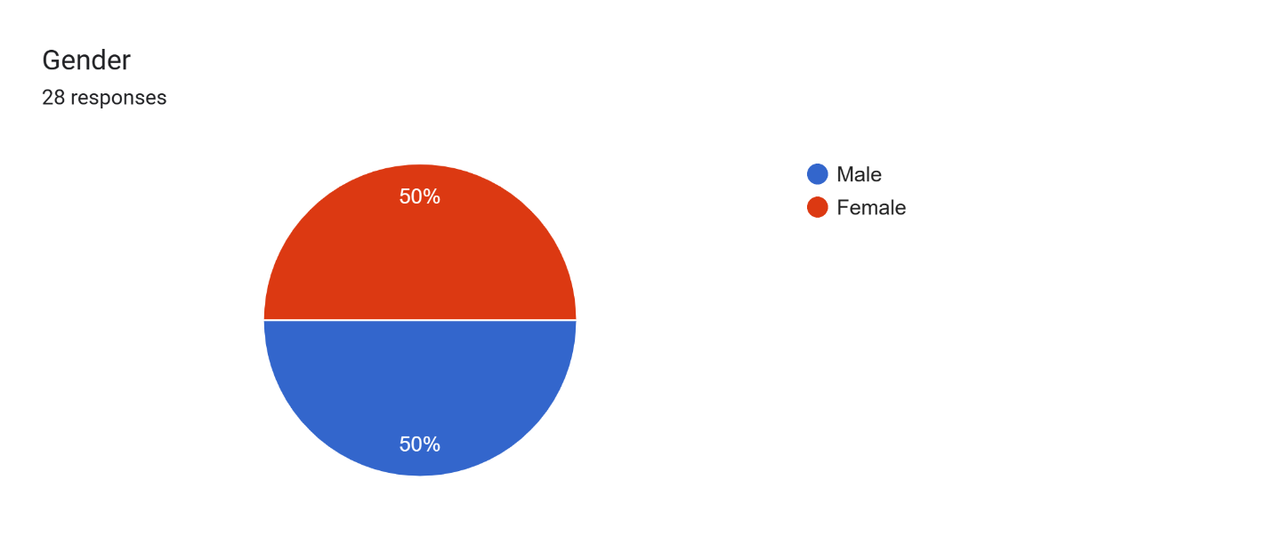

50% are womens

Most of the people found it difficult but still some of them found that it was learning means interview made them learn. A same amount of people found it average which shows the diversified population.

Q3) Level of Education
- Post Graduate
- Graduate
- Undergraduate

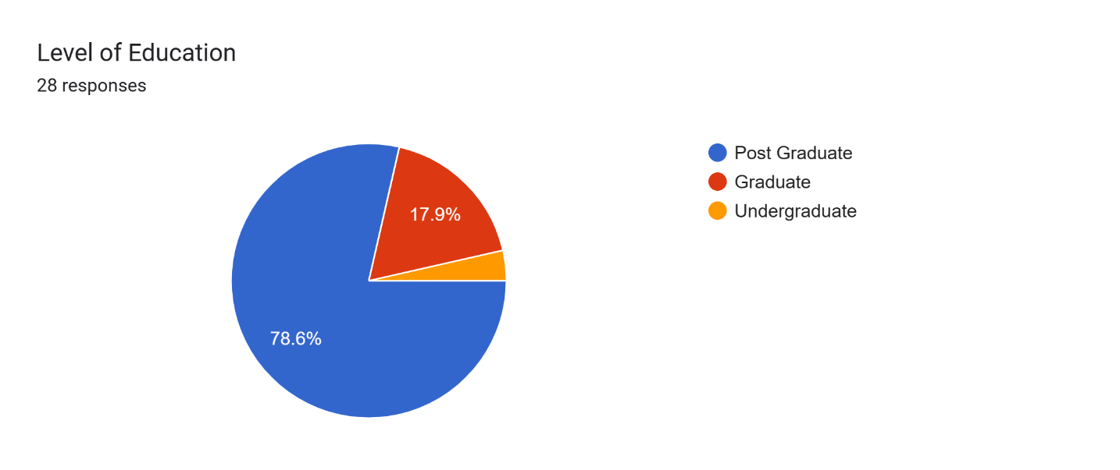

EQ test is used to measure the Personality and traits of the respondent. This is really helpful in measuring the feasibility of prospective employees. Most of the sample found the EQ test Average.

Q4) Salary
- 10k to 20k
- 20k to 30k
- 30k to 40k
- above

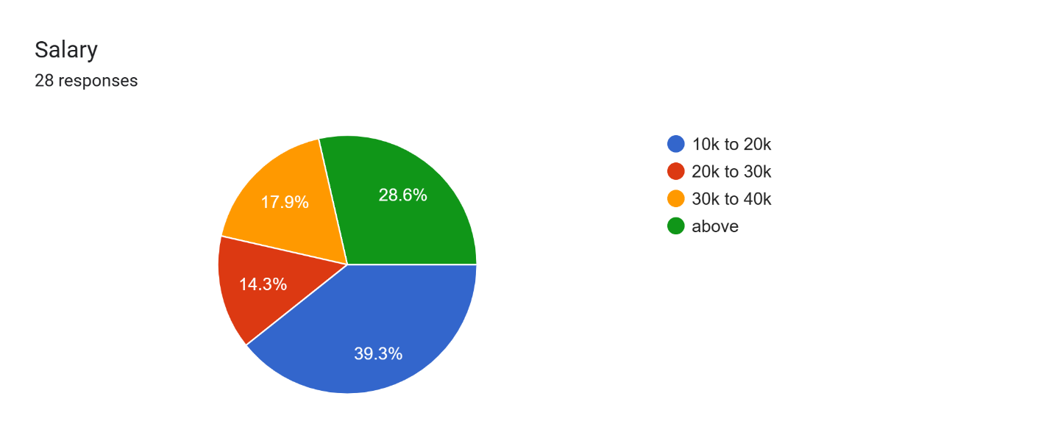

Most of the sample found it good means the training given before hand is helpful in attaining the targets given them. There were also people who found it really excellent.

Q5) Level of Job Satisfaction
- Excellent
- Good
- Average
- Below Average
- Poor

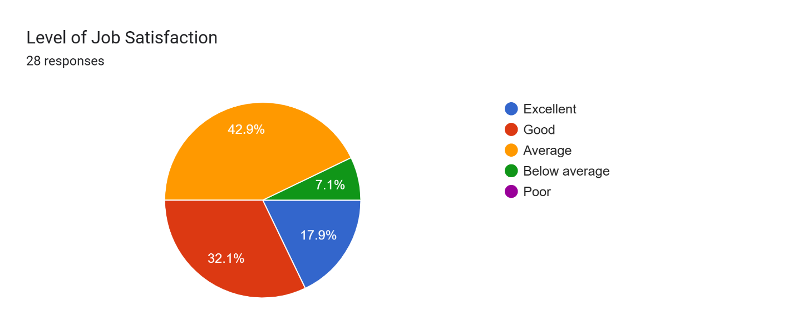

The HR department is the backbone of any organization. They are the one who not only prepare but choose prospective employees. A big chunk of people found it responsible and goal oriented. But it came as a result that they were not too motivatin which is a prerequesite of HR.

WORK ENVIRONMENT

Q6 Decoration in the company makes me comfortable
- Strongly Agree
- Agree
- Neutral
- Disagree
- Strongly Disagree

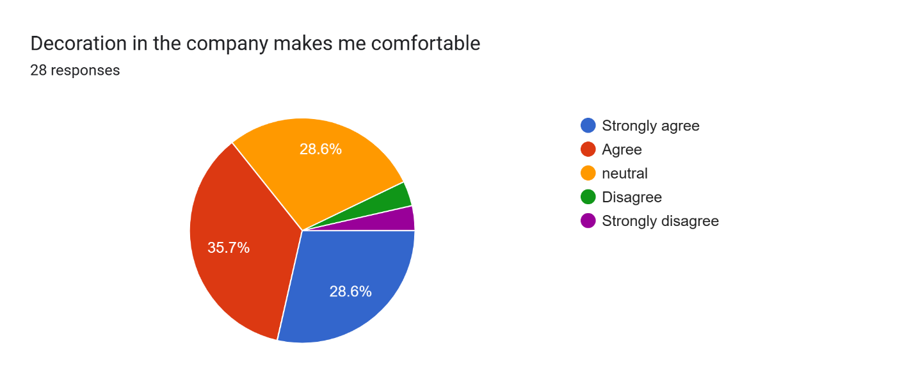

The HR were responsible and most of the employees in time got the information regarding their joining dates.

Q7) the Company provides adequate working equipments
A) Strongly Agree
B) Agree
- Neutral
- Disagree
- Strongly Disagree

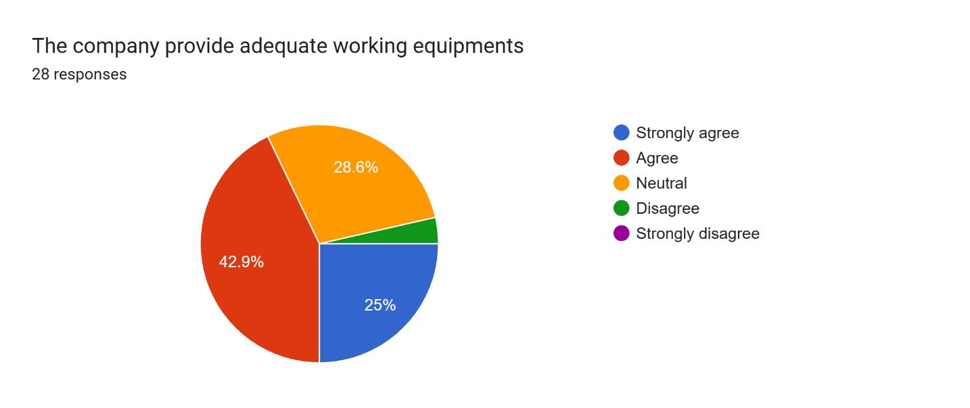

Again the HR played a good role and most of the sample was aware of responsibilities they have to take up. They have been told clearly the roles and they were aware of the policies etc.

8) The working condition of the company makes me feel comfortable
A) Strongly Agree
B) Agree
- Neutral
D) Disagree
- Strongly Disagree

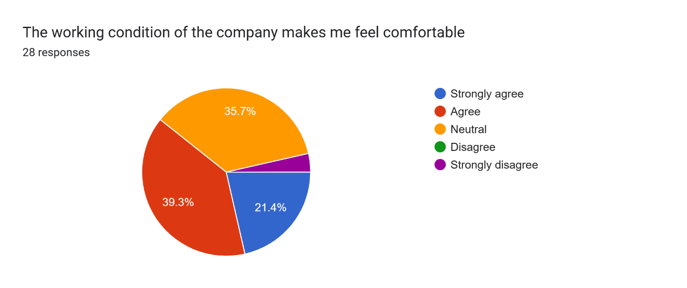

Q8) the company supervision support the subordinate
- Strongly Agree
B) Agree
- Neutral
- Disagree
- Strongly Disagree

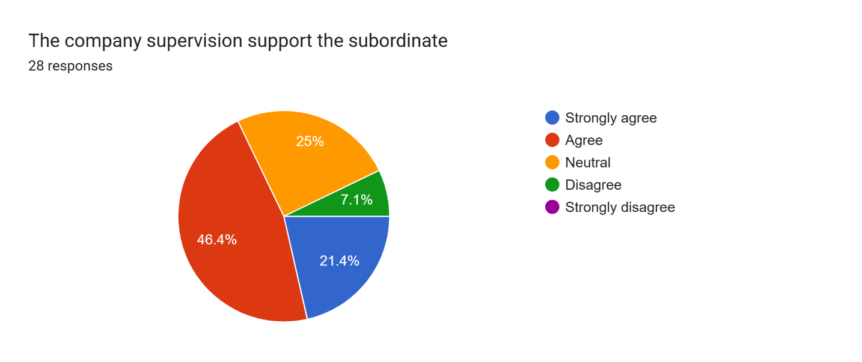

Q9) Atmosphere in the company is pleasant
- Strongly Agree
- Agree
- Neutral
- Disagree
- Strongly Disagree

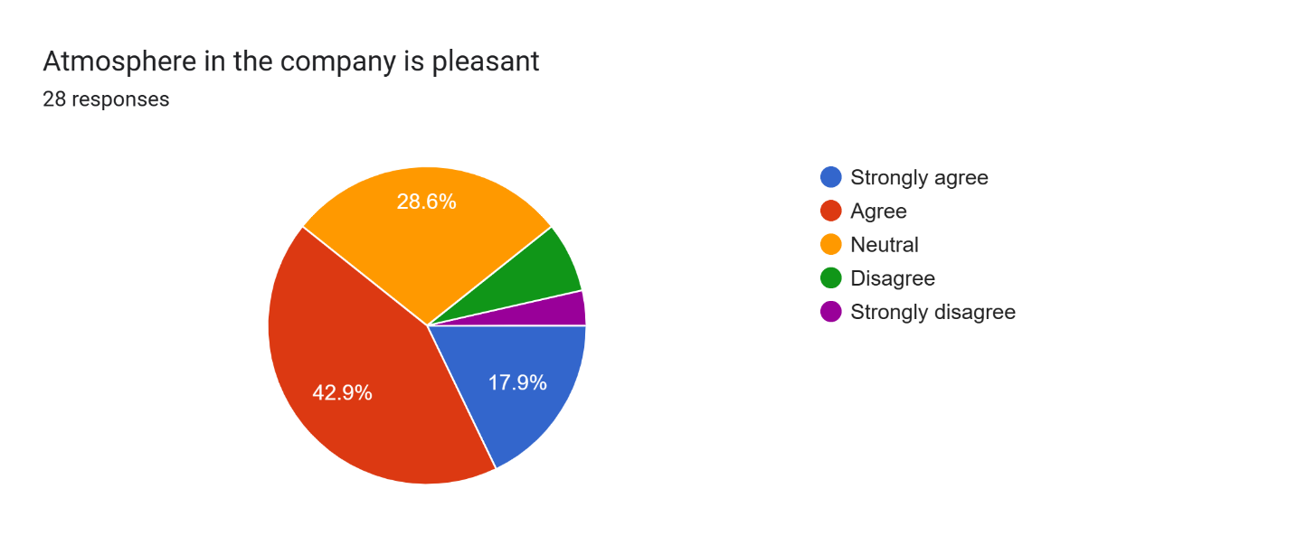

About half of the sample found the induction program excellent. Least votes were for below average. Means the induction program was successful.

Q11) the companies hire manager staff performs their job very well
- Strongly Agree
- Agree
- Neutral
- Disagree
- Strongly Disagree

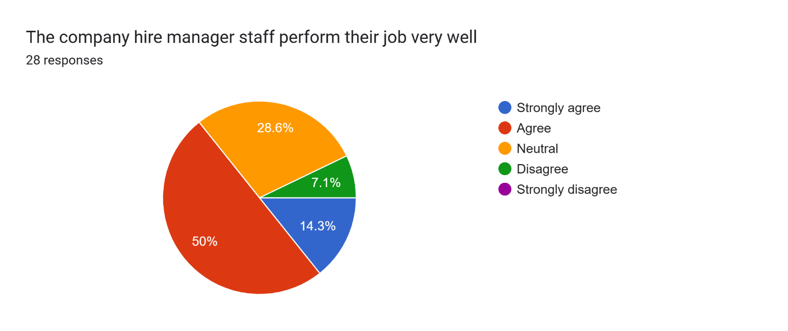

All the components of HR made it success as more than half of sample said that the selection process was excellent. No one voted for below average. So it was a successful process.

12) The company employees are closed to each other
A) Strongly Agree
- Agree
- Neutral
- Disagree
- Strongly Disagree

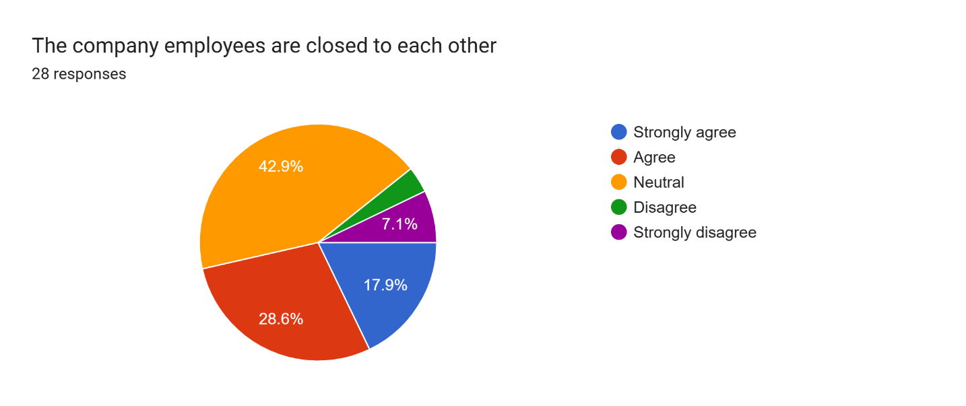

13) The company provides safe working condition
- Strongly Agree
- Agree
- Neutral
- Disagree
- Strongly Disagree

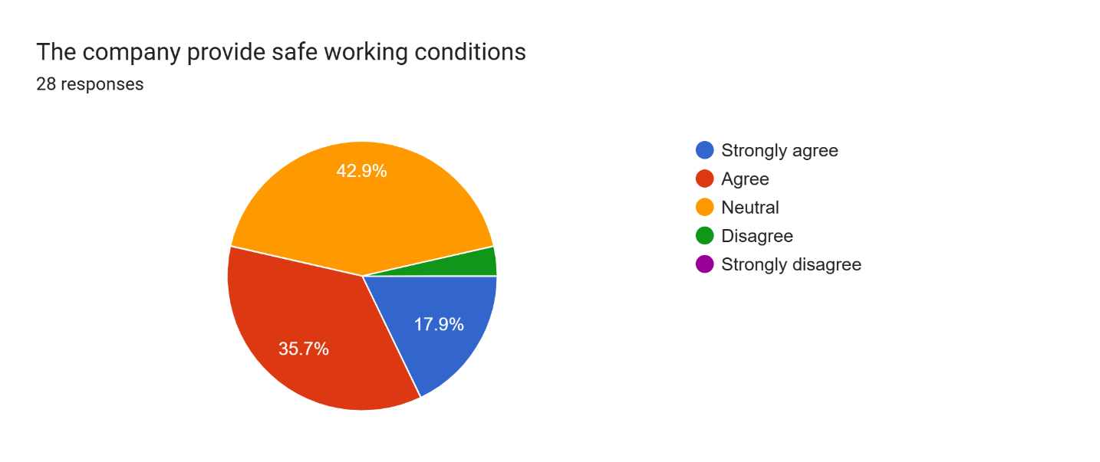

14) The company manager is approachable and helpful
- Strongly Agree
- Agree
- Neutral
- Disagree
- Strongly Disagree

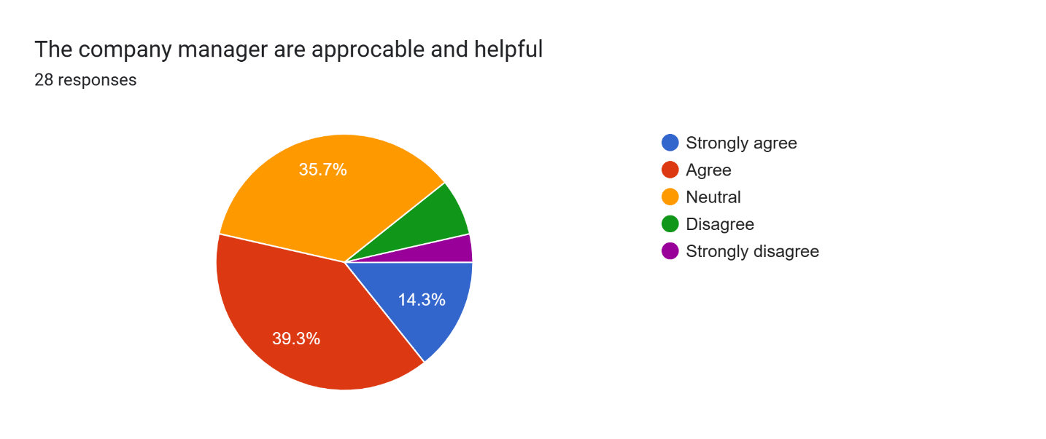

PAY AND SALARY
15) The company basic salary is reasonable
- Strongly Agree
- Agree
- Neutral
- Disagree
- Strongly Disagree

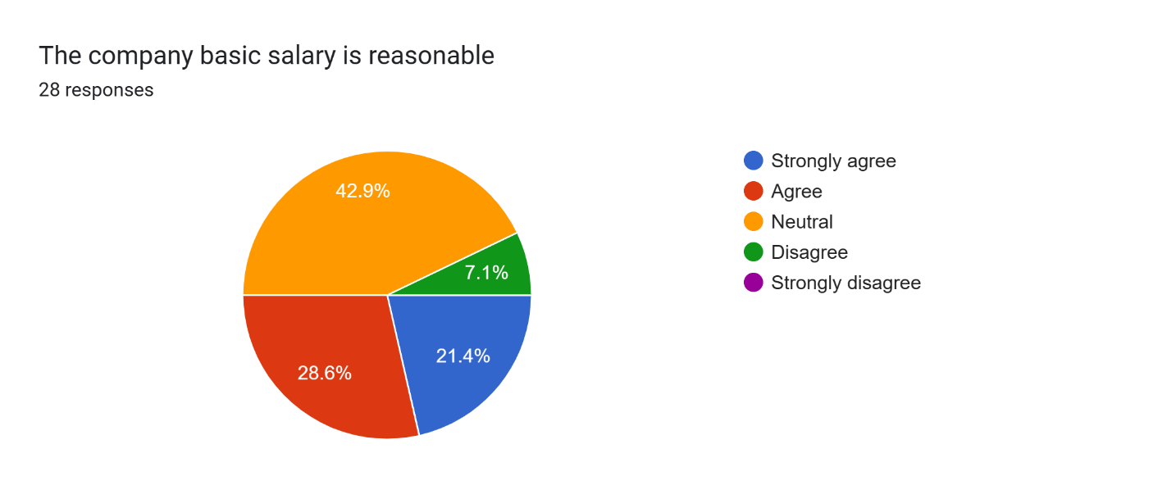

16) The company benefit system is fair
- Strongly Agree
- Agree
- Neutral
- Disagree
- Strongly Disagree

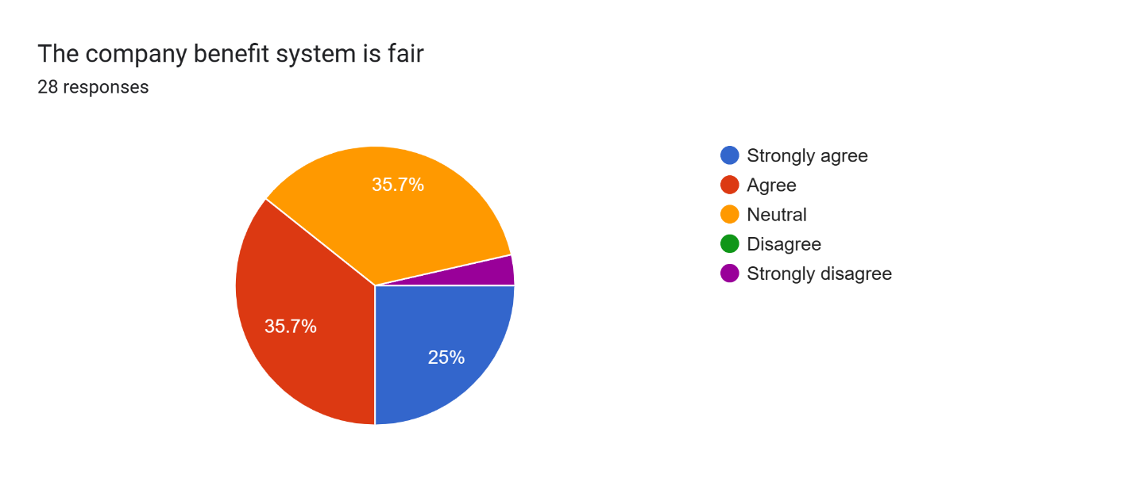

17) Every employee’s salary is at par with their position
- Strongly Agree
- Agree
- Neutral
- Disagree
- Strongly Disagree

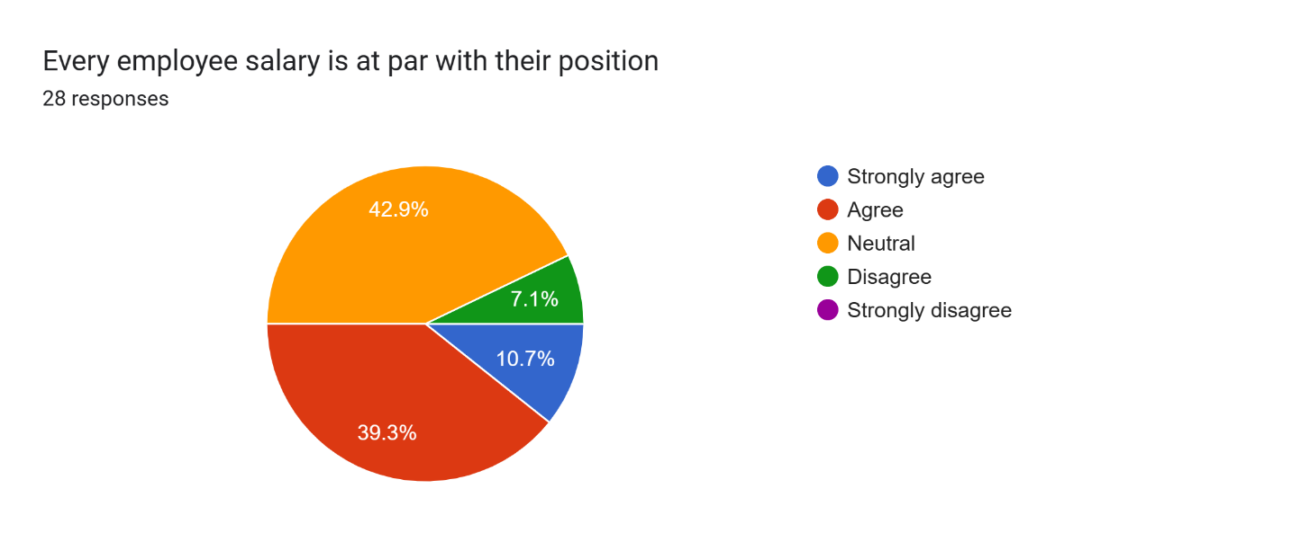

18) Every employee’s salary is at par with their skill and knowledge
- Strongly Agree
- Agree
- Neutral
- Disagree
- Strongly Disagree

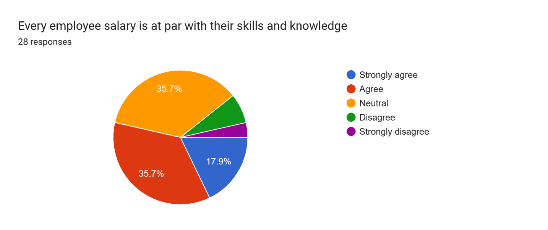

19) The over time payment is reasonable

- Strongly Agree
- Agree
- Neutral
- Disagree
- Strongly Disagree

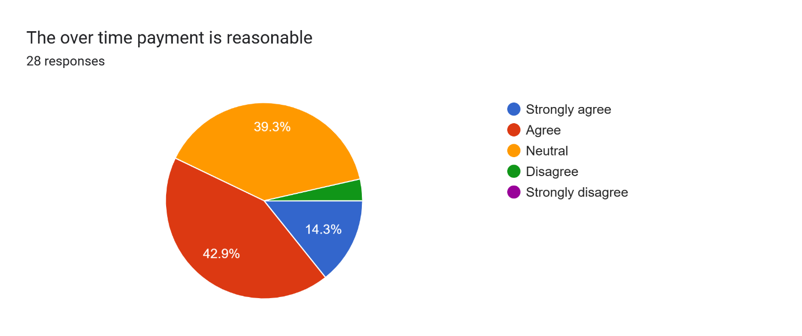

FAIRNESS
20) The company’s basic salary is reasonable
- Strongly Agree
- Agree
- Neutral
- Disagree
- Strongly Disagree

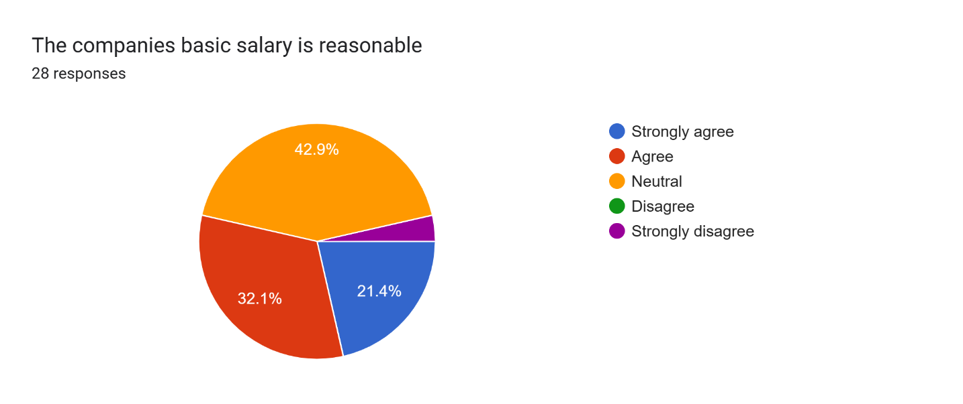

21) The company’s benefit system is fair
- Strongly Agree
- Agree
- Neutral
- Disagree
- Strongly Disagree

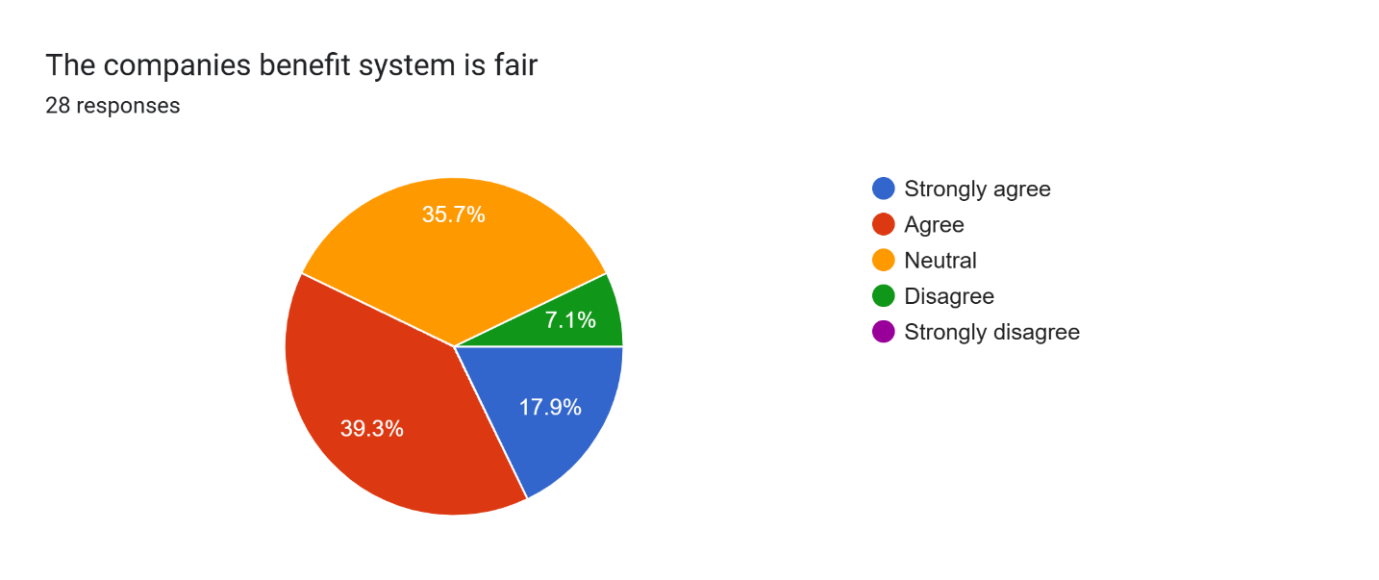

22) Every employee salary is at par with their position
- Strongly Agree
- Agree
- Neutral
- Disagree
- Strongly Disagree

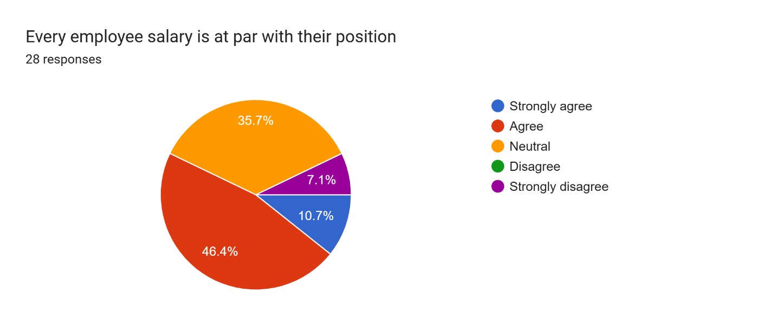

23) Every employee salary is at par with their skills and knowledge
- Strongly Agree
- Agree
- Neutral
- Disagree
- Strongly Disagree

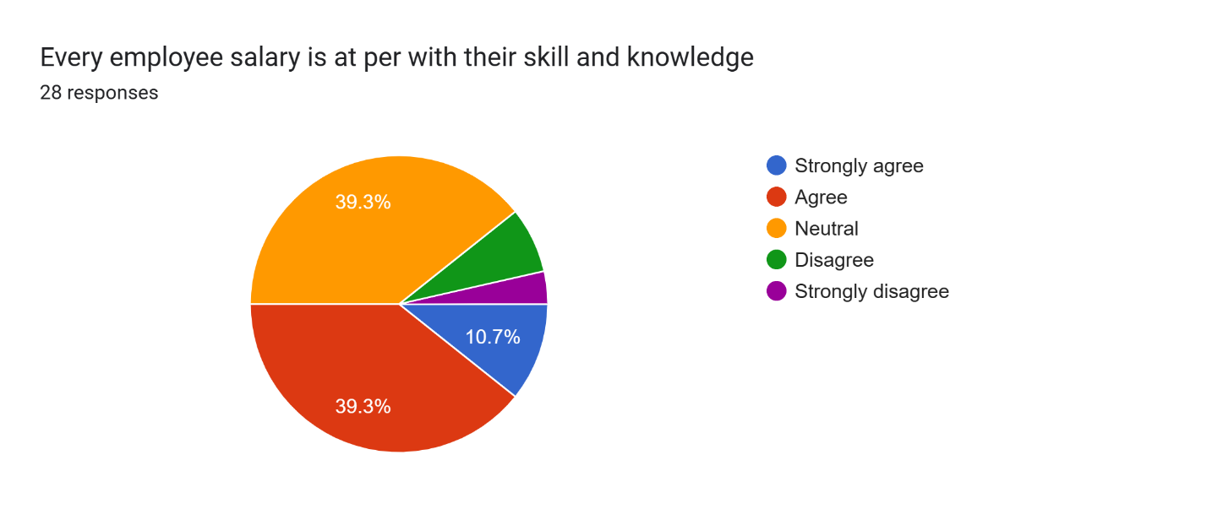

24) The overtime payment is reasonable
- Strongly Agree
- Agree
- Neutral
- Disagree
- Strongly Disagree

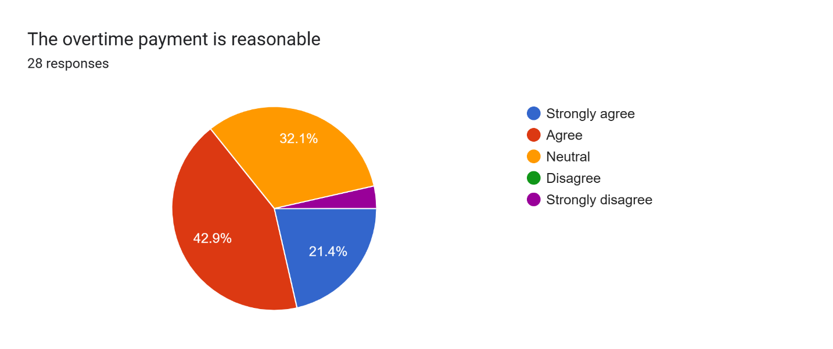

PROMOTION CRITERIA
25) The company’s basic salary is reasonable
- Strongly Agree
- Agree
- Neutral
- Disagree
- Strongly Disagree

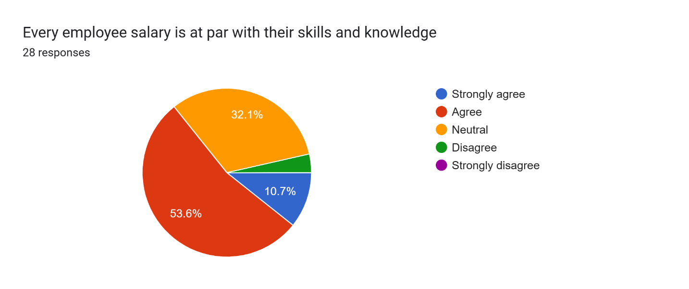

26) The company’s benefit system is fair
- Strongly Agree
- Agree
- Neutral
- Disagree
- Strongly Disagree

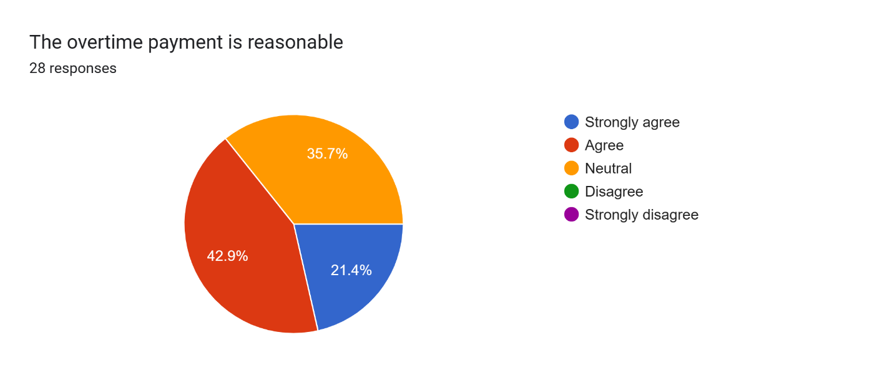

27) Every employee salary is at par with their position
- Strongly Agree
- Agree
- Neutral
- Disagree
- Strongly Disagree

28) Every employee salary is at par with their skills and knowledge
- Strongly Agree
- Agree
- Neutral
- Disagree
- Strongly Disagree

29) The overtime payment is reasonable
- Strongly Agree
- Agree
- Neutral
- Disagree
- Strongly Disagree

FINDINGS OF THE STUDY

The study found that university Policy protects all employees and applicants for employment against discrimination on the basis of race, religion, color, national origin, ancestry, age, gender, gender identity or expression, disability, a typical hereditary cellular or blood trait, domestic partnership and civil union status, marital, or veteran status.

- It is seen that the hiring authority conducts a broad search that will result in a representative applicant pool. Ideally, the applicant pool will reflect the racial and gender makeup of all people qualified for the position. The responsibility for choosing the successful candidate from among those who are eligible and qualified belongs to the hiring authority alone.

- Certain work environments have been found to carry health risks for specific classes of individuals. When advertising for positions in which there is a risk of health to some individuals within a class, no restrictions should be placed on the applicants from that class.

- The hiring authority provide interviewers with a list of clearly defined questions designed to determine whether candidates are qualified and can perform the essential functions of the job.

- Under equal employment opportunity law, the employer should normally select the candidate with the best overall qualifications; however, other job related qualities such as hours, salary, availability and other factors may be considered as long as they are not discriminatory.

- Reasonable accommodations for the disabled are modifications or adjustments that can be made without undue hardship to allow a qualified individual to enjoy equal employment opportunities. If an accommodation appears to cause undue hardship, that decision should be confirmed through the chain of command within the administrative unit in consultation with the Office of Employment Equity.

- Whether or not the applicant is a citizen should not influence the selection decision.

- Do not notify rejected candidates until a candidate has been selected.

- If HR department found that there are questions concerning choosing among equally qualified candidates, then they must contact the Office of Employment Equity.

CONCLUSION

Recruitment and selection & HRD activities are important functions of the personnel department. These activities are in continuous process and are constantly integrating he the organization and individual needs. Recruitment is of the most crucial roles of the human resource professionals. The level of performance of and organization depends on the effectiveness of its recruitment function. Organisations have developed and follow recruitment strategies to hire the best talent for their organization and to utilize their resources optimally. A successful recruitment strategy should be well planned and practical to attract more and good talent to apply in the organization.

RECOMMENDATIONS

Based on the results from the study and conclusions drawn from it, the following recommendations are spelt out: As the lower level employees are not included in the decision making process, they might not feel important to the organization. Their involvement in the decision making process will motivate them and will make them feel more challenged with what they are doing. From this they will also learn more about the organisation. On the contrary some might think it is too soon to involve new employees in this decision making process but just attending in this kind of meeting will make them more motivated. The organization should also provide more tools and resources as it is a busy place in which adequate tools and resources can improve the speed of the employees work and thus the employees will have more satisfaction with their provided tools and resources. Due to the generally inadequate image the organization has, it needs to embark on an intensive awareness programs such as event sponsorship, which is also a good public relations tool. Through this the organization will become more involved with the public. This will enhance the organization reputation and also intensify employee’s attachment toward this organization.
i. Working environment should be healthy and comfortable enough to work.
ii. Working hours should be in accordance with the existing labor law.
iii. Preference should be given on choice of employee about transfer if possible.
iv. Employees should be awarded according to their job performance.
v. Entertainment facilities will be given to employees which removes boringness of employees.
vi. The job should be interesting enough, so that it must create enthusiasm among the employees.

CONCLUSIONS
Every organization depends on their manpower for success and development. In-fact, if workers or employees work properly, the organization can easily achieve the target. To get the best out of the employees in work, proper attention must be given to enhance their job satisfaction level. While studying the job satisfaction level of employees of DIGITAL IMAGINATIONS 7 FOX PVT LTD.
Organization, the finding is that on average they were satisfied with their jobs. Although some weaknesses exist in contents of pay structure, other facilities, performance Appraisal system, Career Development System and Promotion system, the organization can easily overcome them through improvement measures. This tries to link between theoretical knowledge and practical knowledge of employee job satisfaction and tries to show the exact position in graphical presentation. From this study, it can be understood that satisfaction is subjective. It varies from person to person. From the findings, it clearly noted that job satisfaction, organizational culture, and job performance is related with one another. If these three show positive, job engagement will be ensured, motivation of employees will be increased. The objectives of this study have
not been fulfilled with complete satisfaction. However, I gave my highest effort to achieve the objectives

BIBLIOGRAPHY



